Year 10
Pathway 2

End of Term 1 Test

2018


Name: ______________________ Class: ______ Time: 55 minutes Total Mark:____/58

Show working and answers on this sheet. Show working in sufficient detail to support your answers. Incorrect answers without supporting reasoning will be allocated zero marks.

Resources: 1 A4 page of notes (1 side), Calculator allowed.

Algebra

Question 1 2 marks

Simplify the following.

- b)

Question 2 4 marks

If a = -4, b = 6 and c = 3 calculate the following.

a) a + b + c = b) 3b – 2c + a =

- (c – a)² = d) 6a – 5c =

Question 3 6 marks

Simplify the following indices. Give your answers as positive indices.

Simplify the following indices.
- b)

- d)

e) f)

Question 4 1, 2, 2, 1- 6 marks

Expand and simplify the following:

- 2(2x – 3y + 5) c) (x - 2)(x + 4)

- (2m + 2)(m – 4) d) -5(2a - 2b + c)

Question 5 1, 1, 2, 2, 2 -8 marks

Simplify the following algebraic fractions:

a) $\frac{4a}{2}$ b) $\frac{2a}{10}+\frac{5a}{10}$ = c) $\frac{9z}{10}-\frac{3z}{5}$ =

d)$\frac{6b}{3} \frac{4b}{10}$ = e) $\frac{5d}{6} ÷\frac{5d}{8}$ =

Factorising

Question 6 3 marks

Factorise the following: (Hint one bracket ( ) )

a) 15c – 5 b) $2x+4x^{2}$ c) 36ab + 12cb

Question 7 4 marks

Fully factorise each of the following. (Hint two brackets)

(a) 3(a – 1) + b(a – 1) (b) 2p(3w + 2) – 3(3w + 2)

Surface Area

Question 9 2, 3, -5 marks

Determine the surface area of the following 3D Shapes:
a)

b)

Question 10 8 marks

Calculate the surface area of the following composite solids
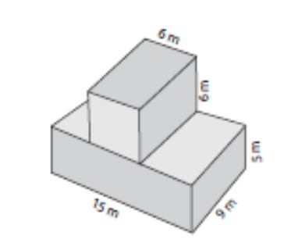
a)

Question 11 3 marks

Calculate the surface area of a cylinder with base radius of 10 cm and a height of 26 cm.
(HINT: Draw a diagram and use the formula if needed)

Volume

Question 12 2 marks

Count the cubes and calculate the volume of each prism. (Each cube is 1cm³.)
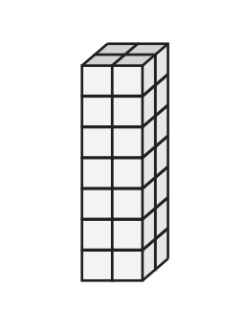
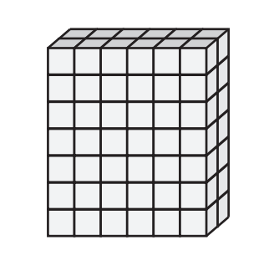
- b)

Volume =_______________ Volume =_______________

Question 13 2 marks

Work out the area of the triangle and use your answer to
find the Volume of the shape.

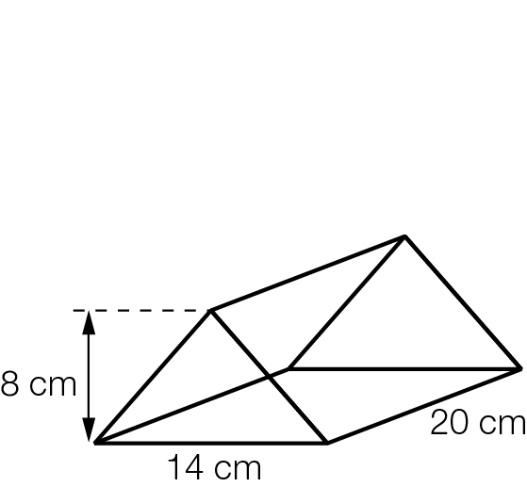

Question 14 4 marks

Calculate the Volume of the following 3D Shapes.
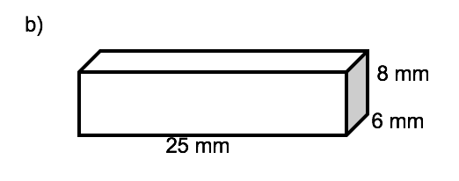
a)

b)

Question 15 3 marks

A cylinder has a volume of 375 cm³ and a height of 15cm, find its radius.

Question 16 4 marks

Calculate the volume of the following solid

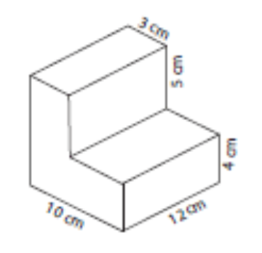

END OF TEST

